**Activities. Tables and Forms**

**Activity 1**

Make the following table. Use CSS rules to style the table. Write information inside the table

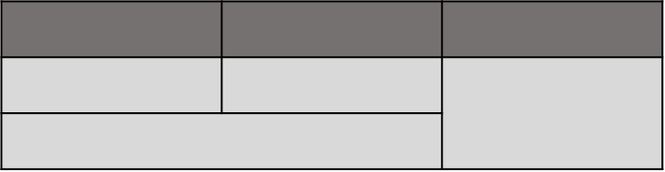

**Activity 2**

Make the following table. Style the table accord the image. The width of the table will take up the widht of the viewport. Use pseudoclass.

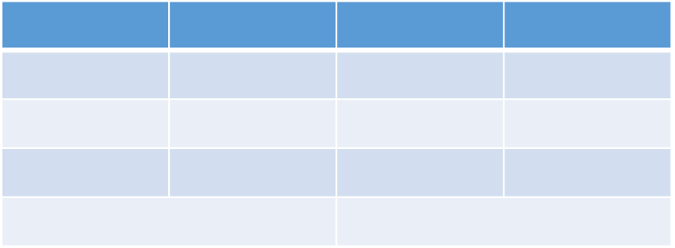

**Actividad 3**

Modify the before activity. The table will be inside a div tag. The width of the div will be smaller than the table. Add scrollbar to see the table.

**Actividad 4**

Add a css rule to one of the above tables so that when you hover over a row its background color is yellow, its orange border, and its font size larger

**Activity 5**

Make a webpage with a form with the next elements.

* Name, con un control de tipo texto obligatorio y con autofoco.
* Mail, con un control de tipo email obligatorio.
* URL, con un control de tipo url que muestre la ayuda "Escribe la URL de tu página web personal".
* Date, con un control de tipo date.
* Week, con un control de tipo week.
* Number, con un control de tipo number que limite la entrada a un valor entre -10 y 10.
* Telephone, con un control de tipo tel.
* Search, con un control de tipo search.
* Color, con un control de tipo color.
* Time, con un control de tipo time.
* Date and time, con un control de tipo datetime.
* Month, con un control de tipo month.
* Datelist
* Button, submit.

Add,

* 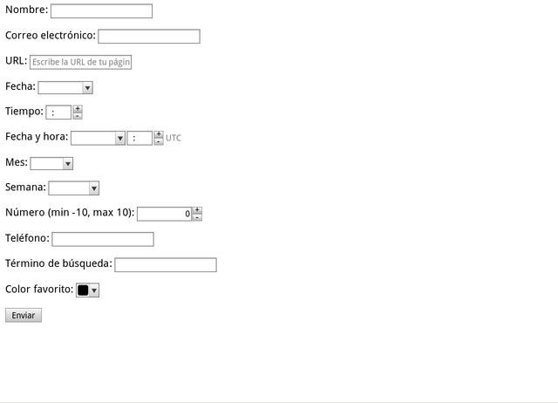Title of the page: Formulario de prueba de HTML5.
* Method: GET.
* Action: "".
* Style your form. Use pseudoclass to control errors.
* At the end, try the webpage in different browsers to compare results.

**Activity 6**

Make a webpage with a form. Try to simulate the form to sign up to a social net. (tuenti, instagram, facebook).